Probability
Jan03 Quesion3

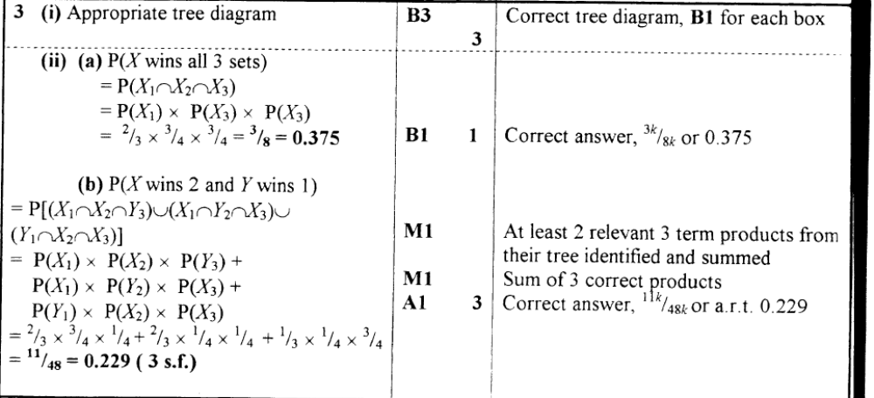

Jan04 Quesion4

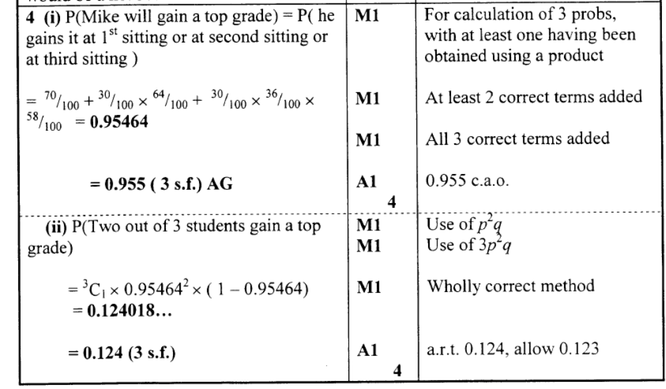
Permutations & Combinations
Jan04 Quesion5

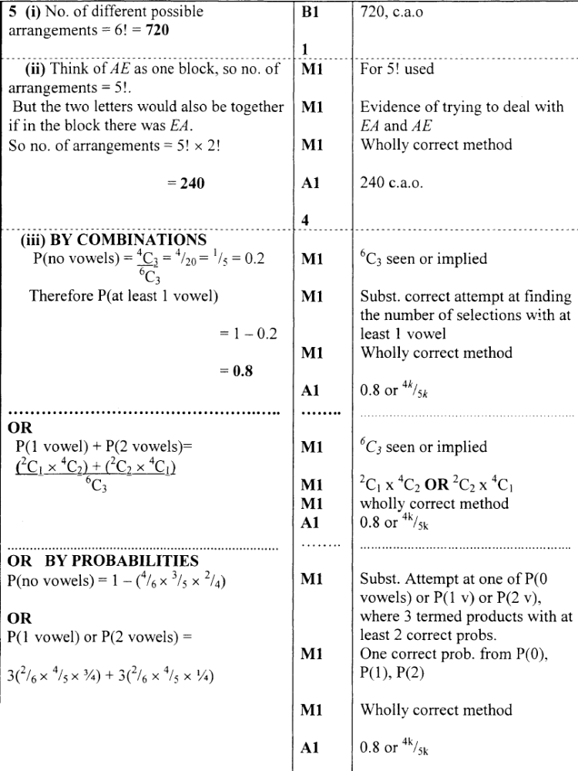
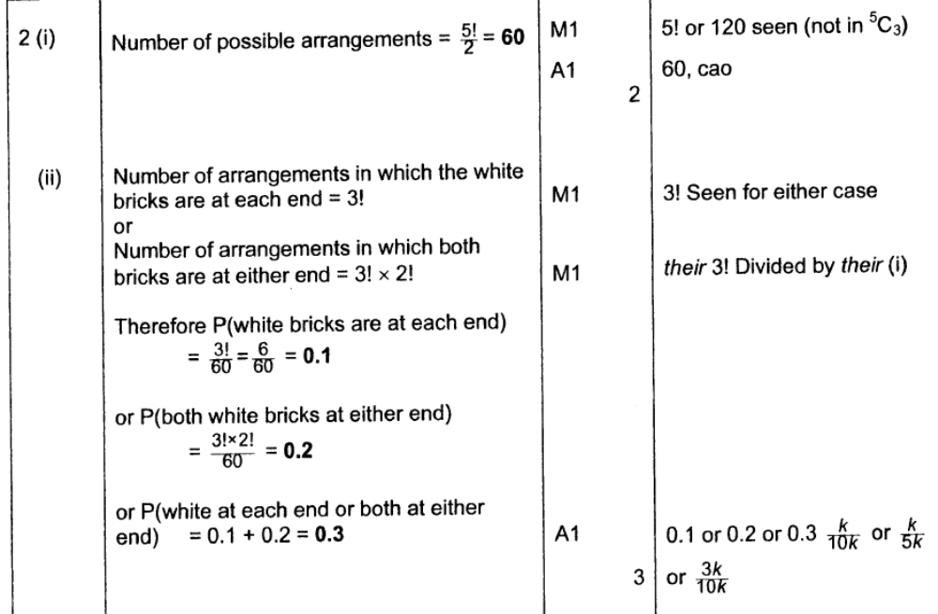
Jun04 Quesion2
Binomial & Geometric Distributions
Jan03 Quesion1
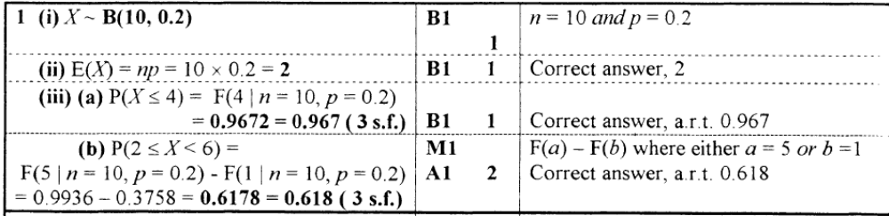
Jan04 Quesion3
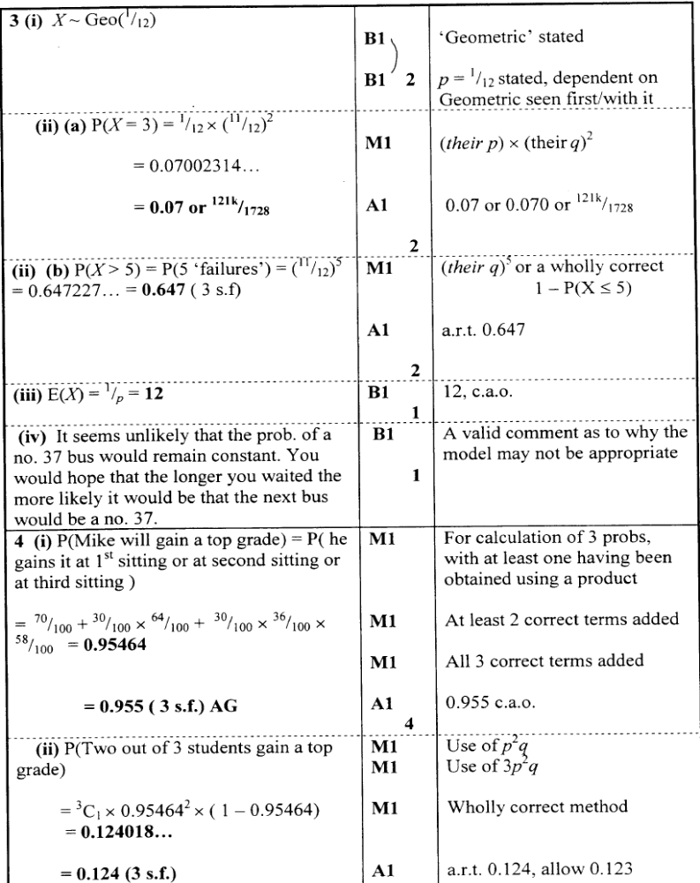

Jun04 Quesion5

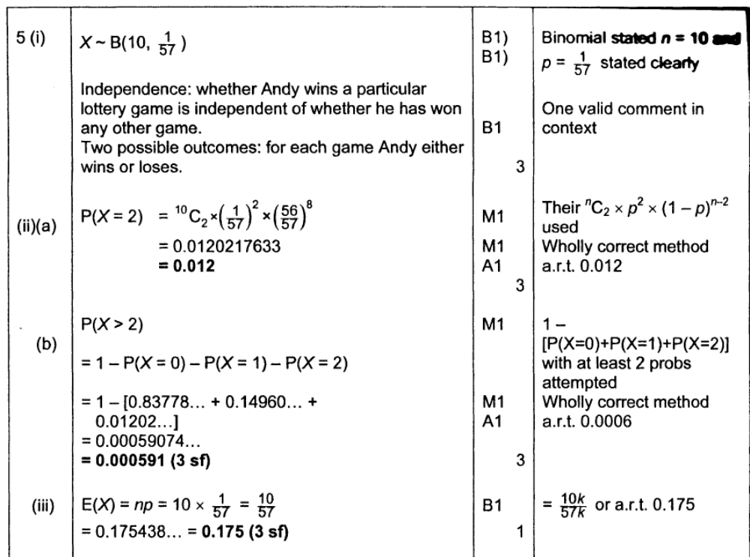
Probability Distributions / Expectations Variance

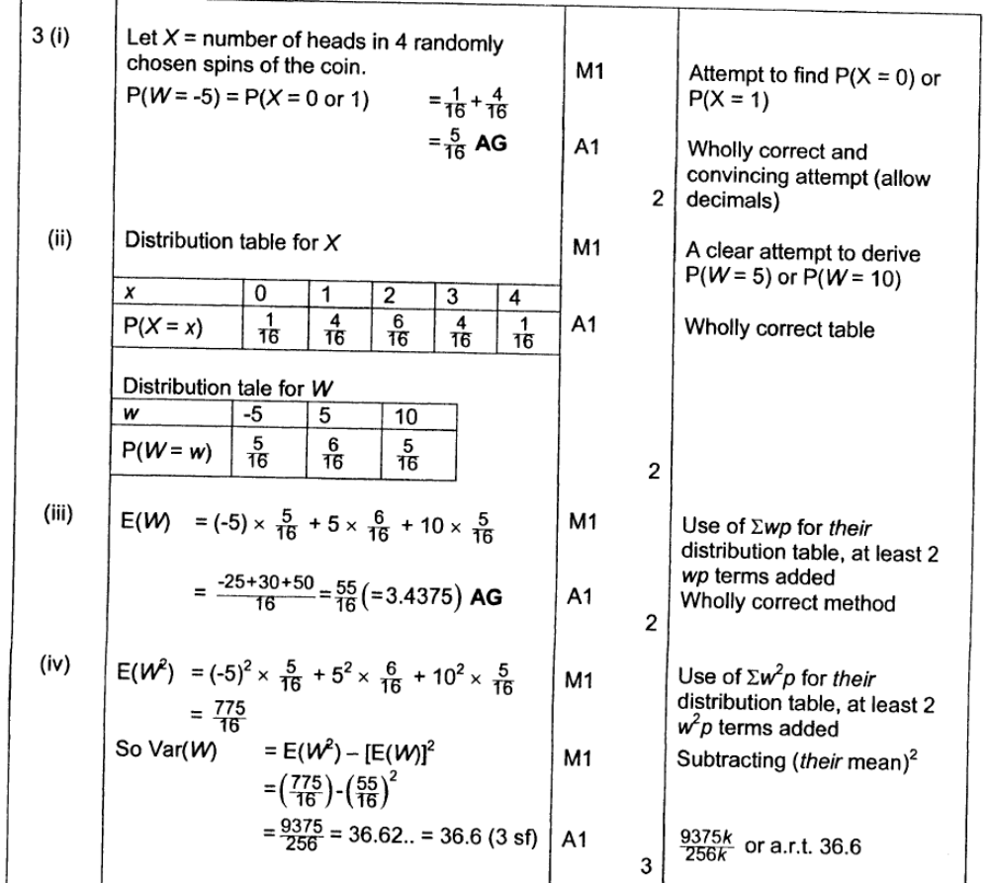
Jun04 Quesion3

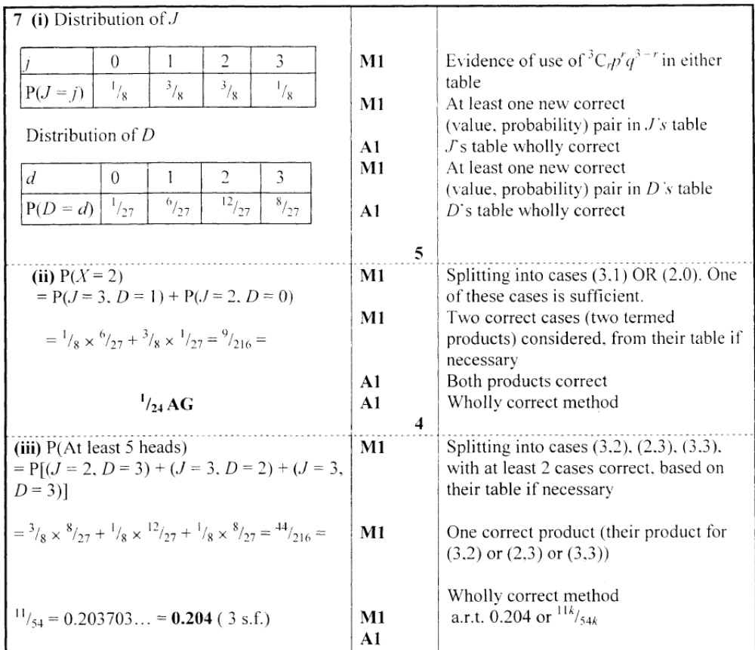
Jan04 Quesion7

